DIGITAL ARDUINO VOLTMETER

AIM:

To design a digital voltmeter using arduino uno

COMPONENTS :

Arduino uno

16\*2 LCD Display

10 Kohm Potentiometer

100 K ohm resistor

10K ohm resistor

Connecting wires

CIRCUIT DIAGRAM :

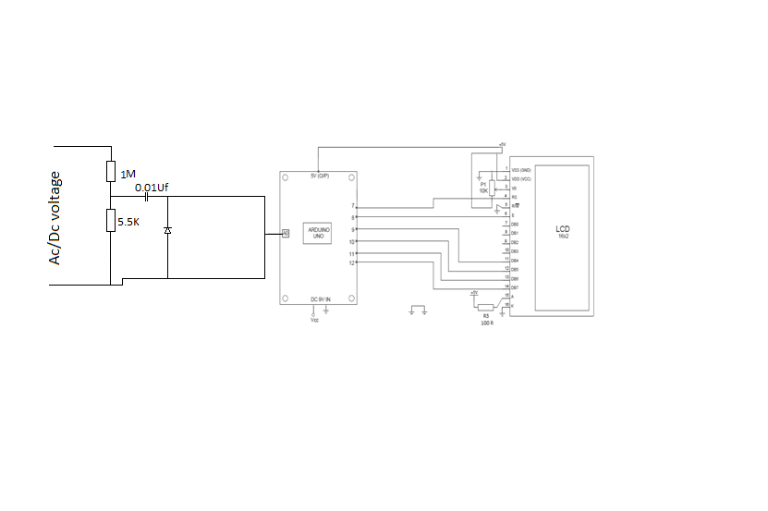

WORKING :

The aim of the project is to build a digital voltmeter using arduino uno . In a digital voltmeter , the voltages to be measured, which are in the analog form, are converted to digital form with help of Analog to digital converters (ADC). Hence, the ADC feature of the Arduino UNO is utilized in this project.

The range of the analog input of Arduino UNO is increased upto 50V by using a voltage divider consisting of 100 Kohm resistor and 10 Kohm resistor. With the help of the voltage divider circuit, the input voltage being measured is brought down to the range of arduino UNOs analog input.

The rest of the calculations are made in the programming part of the arduino UNO

APPLICATIONS :

An Arduino based digital voltmeter is designed in this project which can be used to measure different ranges of DC voltages.

The circuit can be extended to measure even AC voltages with slight modification in circuit and code.